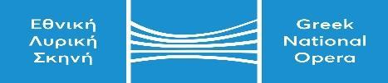
GNO tel. centre: 2130 88 5710 | ΚΑΛΛΙΘΕΑ ….../…………/…………
e-mail : protocol@nationalopera.gr. | Αρ. Πρωτ..…………….

APPLICATION FORM

I wish to participate in the audition for performers for the production of “Strella” on October 31, 2022.

PERSONAL INFORMATION
FULL NAME

FATHER’S NAME

MOTHER’S NAME

BIRTH DATE

BIRTHPLACE

NATIONALITY

PASSPORT No.

VOICE
MUSICAL ACCOMPANIMENT  Mark with an X |  | 1) OWN PIANIST ……………  2) WITH GNO PIANIST ……………
Please mark here with an X if you live abroad or in the provinces and cannot participate physically in the audition, but will do so online on the same day and hours

………………..
CONTACT DETAILS
ADDRESS
TELEPHONE
e-mail
IMPORTANT NOTE: The Audition Committee maintains the right to end an aria/song performance at any time, at its own discretion.

Applicant’s Signature

