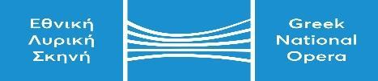

|  |  |
| --- | --- |
| **GNO Offices Call Centre: 2130 88 5710** | **KALLITHEA ….../…………/…………**  **Protocol No..…………….** |
| **e-mail :** [protocol@nationalopera.gr](mailto:protocol@nationalopera.gr). |  |

**MASTERCLASS APPLICATION FORM**

**I hereby request to be included among the active participants who will be selected for Pieter Roijen’s Masterclass at the GNO, on the 12th of June 2025.**

|  |  |
| --- | --- |
| **PERSONAL DATA** |  |
| **NAME & SURNAME** |  |
| **FATHER’S NAME** |  |
| **MOTHER’S NAME** |  |
| **DATE OF BIRTH** |  |
| **PLACE OF BIRTH** |  |
| **NATIONALITY** |  |
| **ID CARD OR PASSPORT NO** |  |
| **MUSICAL INSTRUMENT** |  |
| **PIECE** |  |
| **CONTACT DATA** |  |
| **HOME ADDRESS** |  |
| **TELEPHONE NO(S)** |  |
| **e-mail** |  |

**The signatory**

**(Signature)**