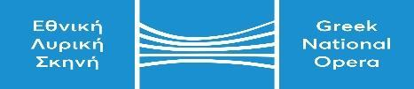
GNO call center: 2130 88 5710 | KALLITHEA ….../…………/…………  Ref.No ..…………….
e-mail : protocol@nationalopera.gr.

APPLICATION FORM
for joining
Adélaïde Ferrière’s Masterclass

Please consider my application for the musician position in
Adélaïde Ferrière’s Masterclass on 5 July 2024.

PERSONAL DATA
NAME & SURNAME
FATHER’S NAME
MOTHER’S NAME
DATE OF BIRTH
PLACE OF BIRTH
NATIONALITY
ID CARD or PASSPORT NUMBER
INSTRUMENT
CONTACT DATA
HOME ADDRESS
TELEPHONE NUMBER
e-mail

Signature

(Signature)

